PreCalculus 1.4

Relation: A set of points with x and y coordinates.

Definition of a Function: A relation where all of the x coordinates only have one y
coordinate.

Is the relation a function?

Every y value has exactly one y value.

X | Y
0 | 0
1 | 4
2 | 5
3 | 7
4 | 9

This relation is a function. All of the y coordinates have different x’s.

X | Y
0 | 1
1 | 2
1 | -2
2 | 4
2 | -4

This relation is not a function. The x value of 1 has two different y values.

X | Y
0 | 1
1 | 1
2 | 1
3 | 1
4 | 1

This relation is a function. All of the y coordinates have different x values.

The Vertical Line Test

If a relation is a function and you draw any vertical line, the line will
touch the graph only one time.

Use the vertical line test to verify if these are functions or not.

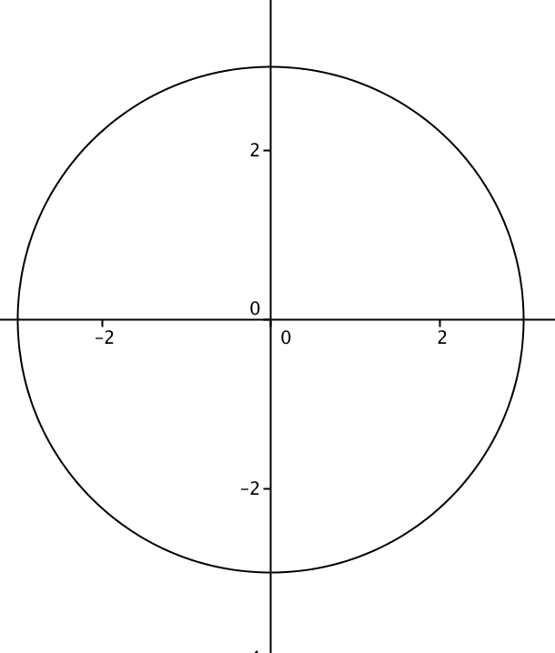
This is not a function as the vertical line would hit two points.

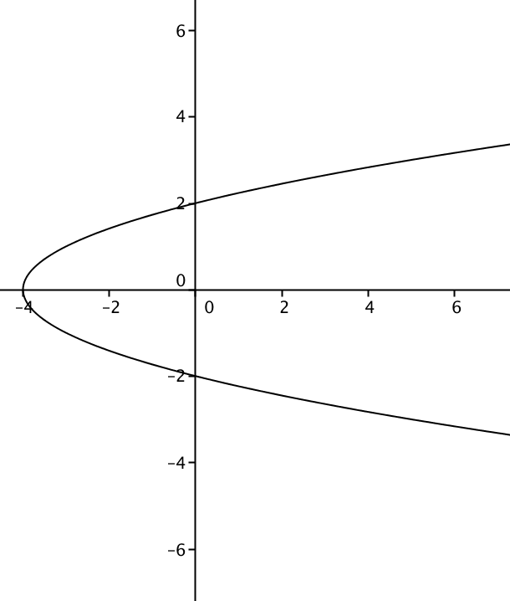
This is not a function as the vertical line would hit the curve twice.

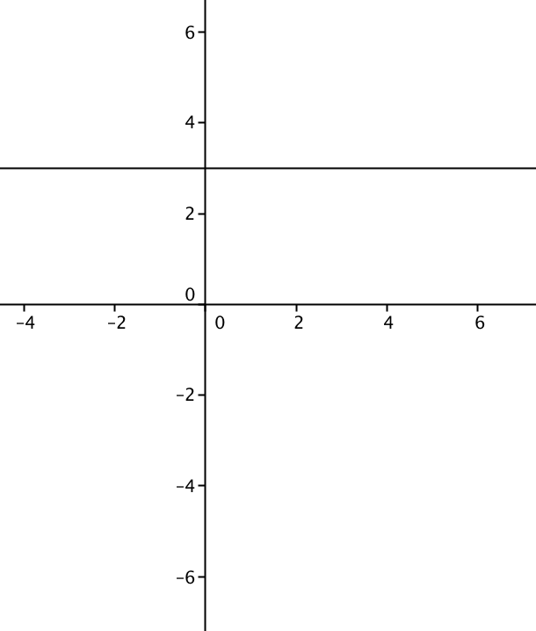
This is a function as any vertical line would just hit the curve one time.

$$y=x^{2}$$

$y$ is a function of $x$

$x$ is the independent variable and $y$ is the dependent variable

Is $y$ a function of $x$ algebraically?

(Solve for $y$ and see if there is only one $x$ value)

$x^{2}+y=1 y=1-x^{2}$ y is a function of x

Is $y$ a function of $x$ algebraically?

(Solve for $y$ and see if there is only one $x$ value)

$x^{2}+y^{2}=16$ $y^{2}=16-x^{2} y=±\sqrt{16-x^{2}}$ y is not a function of x.

Function Notation

$f\left(x\right)=x+3$

This is read “The value of $f$at $x$ is $x+3$.”

$f(x)$ is the same thing as y. We could write this same function as $y=x+3.$

Evaluating a Function

$f\left(x\right)=x^{2}-3x+1$

Evaluate means to put the given value in for the $x$ and solve for $f\left(x\right).$

$f\left(0\right)=0^{2}-3\left(0\right)+1=1$
$f\left(1\right)=1^{2}-3\left(1\right)+1=-1$
$f\left(2\right)=2^{2}-3\left(2\right)+1=-1$
$f\left(t\right)=t^{2}-3t+1$
$f\left(x+3\right)={\left(x+3\right)}^{2}-3\left(x+3\right)+1=x^{2}+6x+9-3x-9+1=x^{2}+3x+1$

Piece-Wise Function

A piece-wise function has different rules for different numbers.

$f\left(x\right)=f\left(x\right)=\left\{\begin{aligned}x, &x<0 \\ -x, &x≥0\end{aligned}\right.$

This function has a negative number for $y$ if $x$ is less than 0.

This function has a positive number for $y$ if $x$ is This will never happen.

$f\left(-3\right)=-3 f\left(0\right)=0 f\left(4\right)=-4$

$$f\left(x\right)=\left\{\begin{aligned}x^{2} if x<0 \\ x if 0≤x<2 \\ 3 if x≥2\end{aligned}\right.$$

Graph this function.

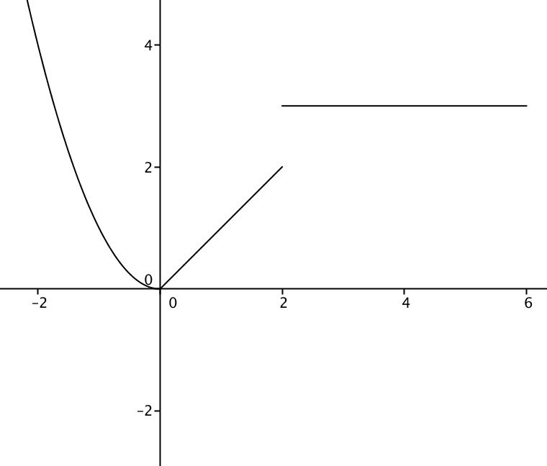

$f\left(2\right)=3 f\left(1\right)=1 f\left(3.14\right)=3$

The Domain and Range of the function

The domain is the x coordinate.

The range is the y coordinate.

Find the domain and range of the following graphs.

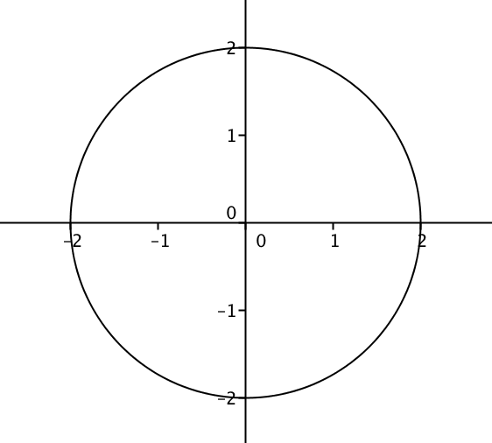

Domain $\left[-2, 2\right]$ Range $[-2, 2]$

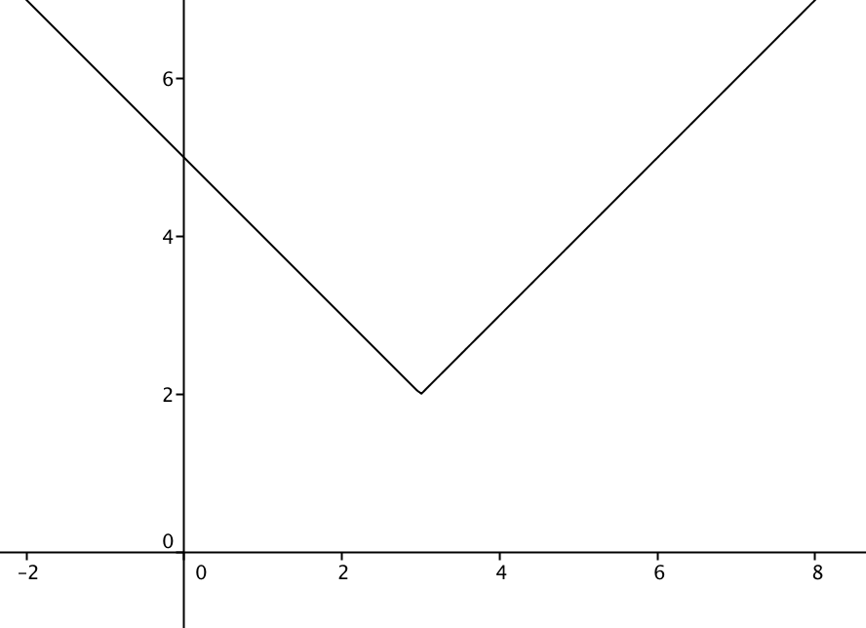

Domain [-2, 8] Range [2, 7]

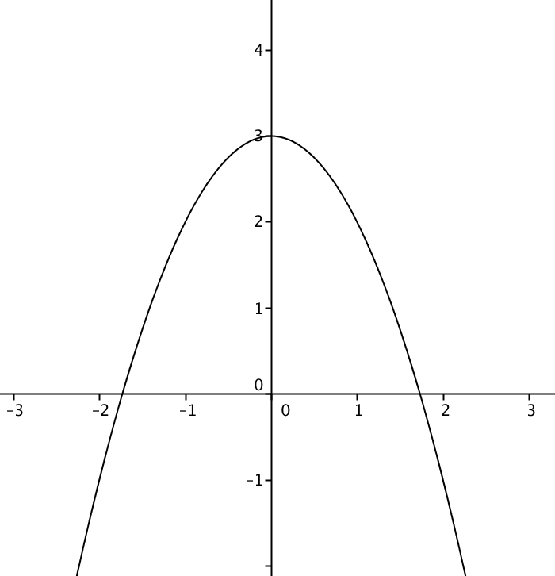

Domain [-2.2, 2.2] Range [-2.2, 3]

