Pre-Calculus 1.2

Determining Solutions

Is $\left(-2,4\right)$ a solution of $y=x^{2}+5x-1$?
Plug in -2 for the x and 4 for the y to see if the equation is true.
$4={\left(-2\right)}^{2}+5\left(-2\right)-1=4-10-1=-7$
The point is not on the curve.

Sketching the Graph of a Linear Equation $3x+2y=12$

Last Resort T Chart

Plug in an x value and find the y values.

X | Y
0 | 6
2 | 3
4 | 0
6 | -3

Find the Intercepts
To find the x-intercept, let $y=0$ and solve for the x value.
To find the y-intercept, let $x=0$ and solve for the y value.

Sketching the Graph of a Function

$y=x^{2}-3$
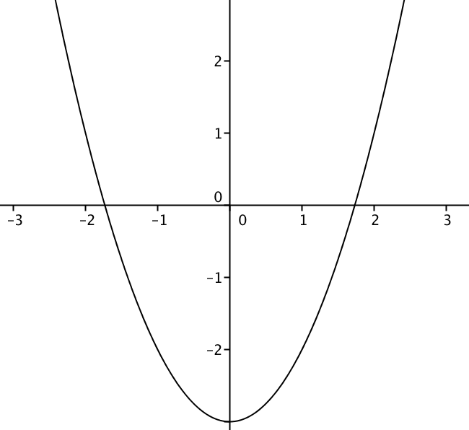

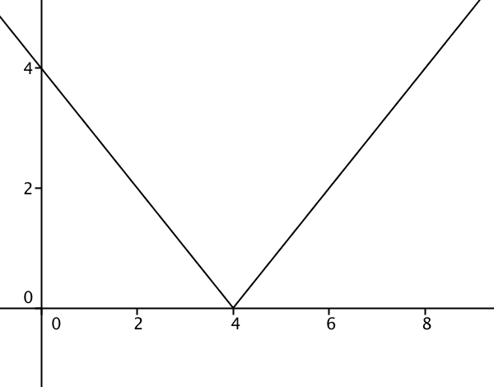

$$y=\left|x-3\right|$$

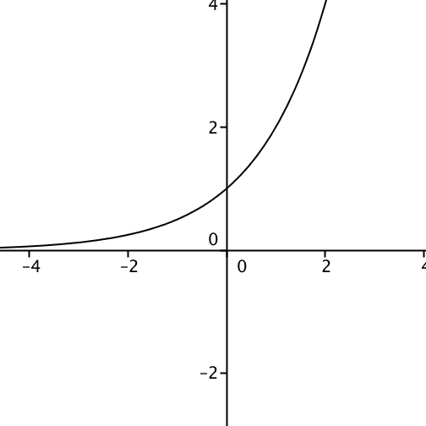

$y=2^{x}$

Symmetry using a graph
x-axis
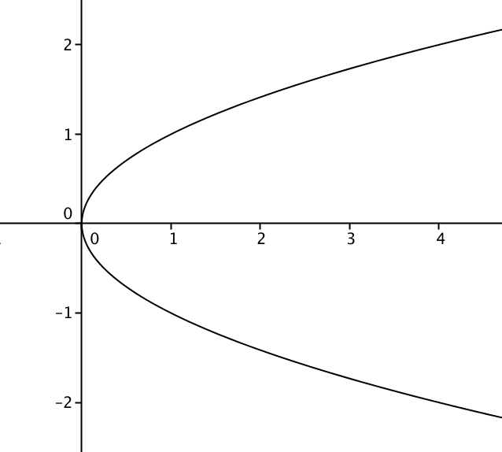

y-axis

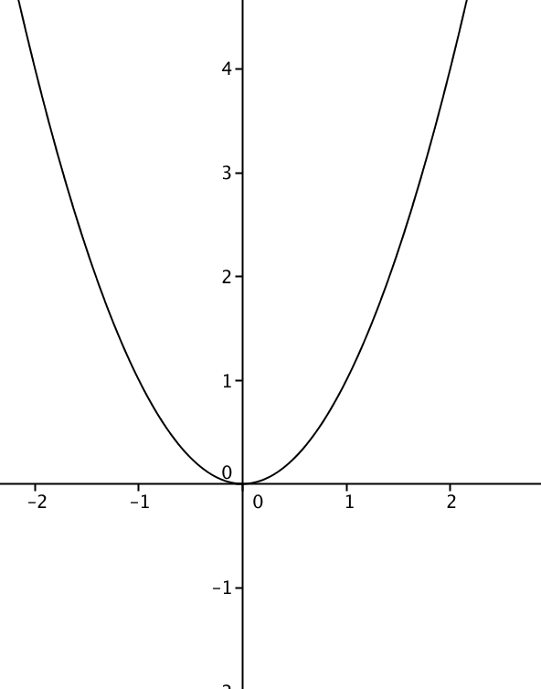

origin

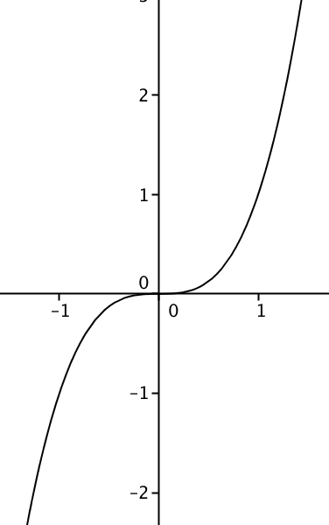

Symmetry using an Equation

X axis
If you can substitute a $–y$ for the $y$and you get the same equation

Y axis
If you can substitute a $–x$ for the $x$ and you get the same equation

Origin
If you substitute a $–x$ and you get the negative of the equation

Equation of a Circle

${\left(x-h\right)}^{2}+{\left(y-k\right)}^{2}=r^{2}$

$(h, k)$ is the center $r$ is the radius

Graphing a circle

