Calculus 1.4 CW

What does $f\left(x\right)=x^{2}$ mean?

$f(x)$ is the same thing as $y.$

$x$ is the independent variable

$y$ is the dependent variable

A function is a relationship between two variables such that to each value of the independent variable there corresponds exactly on value of the dependent variable.

What does this mean?
Every $y$ has only one $x$ coordinate. OR All the $x$’s are different.

Is this a function?

$x+y=1 y=-x+1$ This is a linear function. There is only one y value for each x.

$x^{2}+y^{2}=1 y^{2}=1-x^{2} y=±\sqrt{1-x^{2}}$ This is not a function as there are two y values for every x.

$x^{2}+y=1 y=x^{2}+1$ This is a function as there is only one y value for every x.

$x+y^{2}=1 y^{2}=1-x y=±\sqrt{1-x}$ This is not a function as there are two y values for every x .

Vertical line test

Use the vertical line test to verify if these are functions or not.

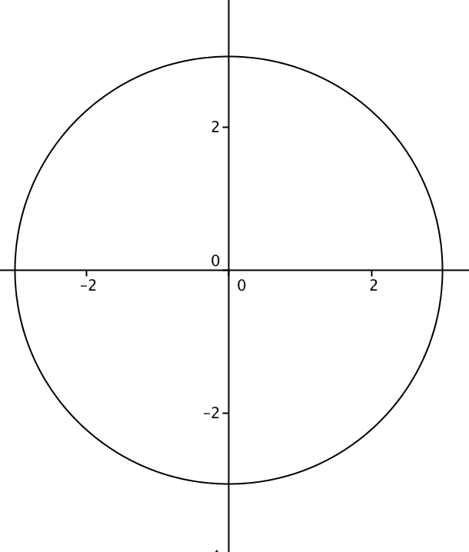 Not a function.

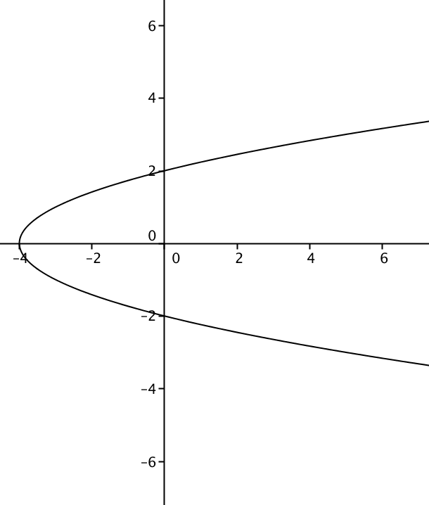
Not a function.

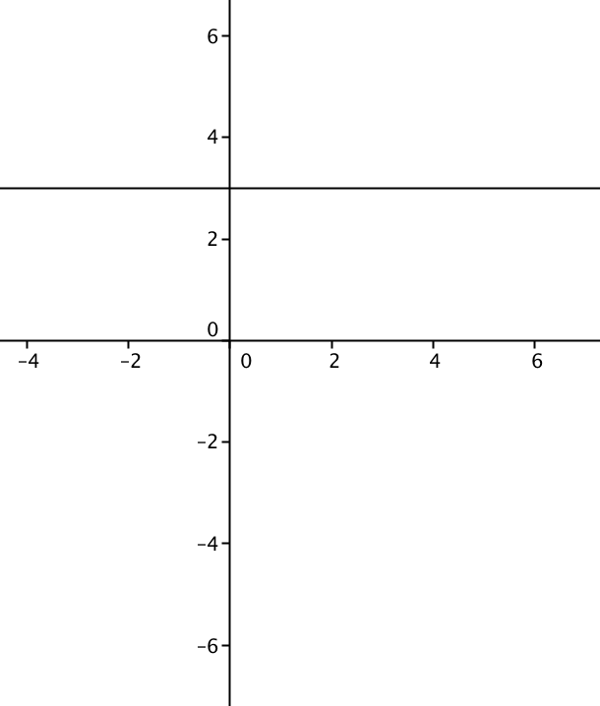

Domain and Range of the Function

The domain is the x coordinate.

The range is the y coordinate.

What is the domain of each function?

Square roots The function under the square root > 0

$f\left(x\right)=\sqrt{x-3}$

$f\left(x\right)=\sqrt{16-x^{2}}$

Denominators

$f\left(x\right)=\frac{1}{x}$

$f\left(x\right)=\frac{(x-2)}{\left(x-2\right){\left(x+3\right)}^{2}}$

Square roots in the denominator

$f\left(x\right)=\frac{1}{\sqrt{x-5}}$

$f\left(x\right)=\frac{3x-2}{(x+4)\sqrt{x^{2}-4}}$

Piecewise Functions

$f\left(x\right)=\left\{\begin{aligned}x+3 x<0 \\ x^{2} x≥0\end{aligned}\right.$

There are two pieces to this graph.

One piece is every $x$ value to the right of 0.

One piece is every $x$ value to the right of 0.

One-to-One Function

A function is one-to-one if it has an inverse. You can check to see if it is one-to-one by using the horizontal line test.

Evaluating a Function:

$f\left(x\right)=2x^{2}-4x+1$

$f\left(-1\right)=$

$f\left(0\right)=$

$f\left(2\right)=$

Is this function one-to-one?

$f\left(x\right)=x^{2}+7$

$f\left(x+3\right)=$

$f\left(x+∆x\right)=$

$\frac{f\left(x+∆x\right)-f(x)}{∆x}=$

Definition of a Composite Function

$\left(f∘g\right)\left(x\right)=f(g\left(x\right))$

$f\left(x\right)=x-4$ $g\left(x\right)=x^{2}$

$f\left(g\left(2\right)\right)=$ $g\left(f\left(2\right)\right)=$

$f\left(g\left(x\right)\right)=$

$g\left(f\left(x\right)\right)=$

Inverse Functions

$g\left(x\right)$ is the inverse function of $f(x)$ if

Find the inverse function.

Steps:

- Switch the variables.
- Solve for $y.$

$f\left(x\right)=2x-1$

$f\left(x\right)=\frac{2x-3}{4x+1}$

$f\left(x\right)=x^{2}-1$

