Calculus 1.3 Lines in the Plane and Slope

What is the slope intercept form? $y=mx+b$

What does each letter stand for? $m=slope, b=y-intercept$

Graph the following lines.

$y=3x+4$

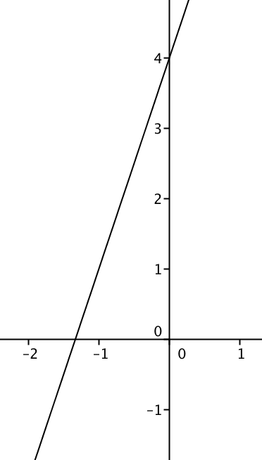

$y=3$
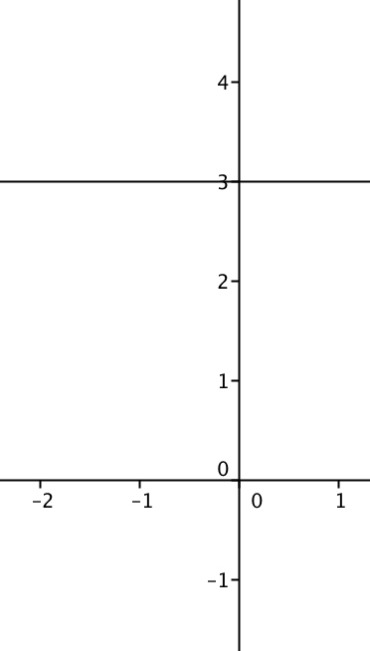

$x+y=4$

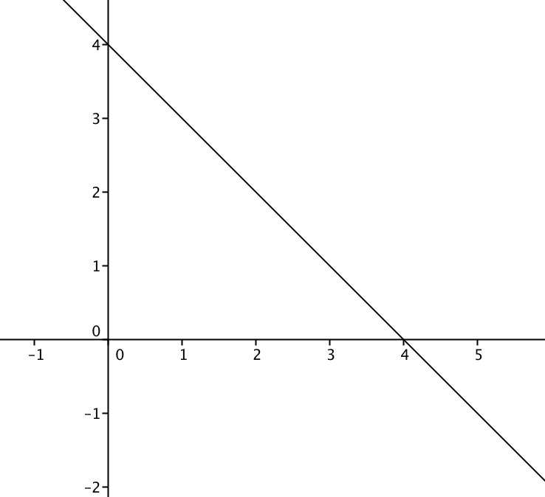

Slope is defined as the change of the y coordinates divided by the change in the x coordinates.

Find the slope between the following points:

(2, 4) (-4, 7) $\frac{7-4}{-4-2}=\frac{-11}{-6}=\frac{11}{6}$

$\left(3, -2\right) \left(-15, -2\right)$ $\frac{-2-\left(-2\right)}{3-\left(-15\right)}=\frac{0}{18}=0$

$\left(4, -2\right)\left(4, 14\right)$ $\frac{14-\left(-2\right)}{4-4}=\frac{16}{0}→$ undefined

When the slope is $\frac{0}{13}$, the slope is 0.

When the slope is $\frac{13}{0},$ the slope is undefined.

What is the point-slope formula? $y-y_{1}=m(x-x_{1})$

If the slope is 3 and the point is (-2, 5), write the equation of the line.
$y-5=3(x+2)$

If the slope is -2 and the point is (4, -9), write the equation of the line.
$y+9=-2(x-4)$

HOY means Horizontal line 0 slope Y = a number

VUX means Vertical line Undefined slope X = a number

The equation of the line passing through (-2, 7) with 0 slope is $y=7$

The equation of the line passing through (3, -12) with undefined slope is $x=3$

What is the general form of a line? $AX+BY+C=0$

Parallel lines have the same slope.

Perpendicular lines have negative reciprocal slopes.

Write the equation of the line parallel to the line $x+y=1$, passing though the point (-2, 3).
Change $x+y=1$to slope intercept form. $y=-x+1$
The slope is -1. The parallel line has slope -1.
$y-3=-1(x+2)$

Write the equation of the line perpendicular to $3x-2y=12$, passing though
(5, -14).

Change $3x-2y=12$ to slope intercept form.
$-2y=-3x+12 y=\frac{3}{2}x-6$
The slope is $\frac{3}{2}$. The perpendicular slope is $-\frac{2}{3}$.

