AB Day 2

Go over HW.

Symmetry using a graph

x-axis $x=y^{2}$

y-axis $y=x^{2} y=\left|x\right|$

origin $y=x^{3}$

Symmetry using an Equation

x-axis $f\left(x\right)=-f(x)$
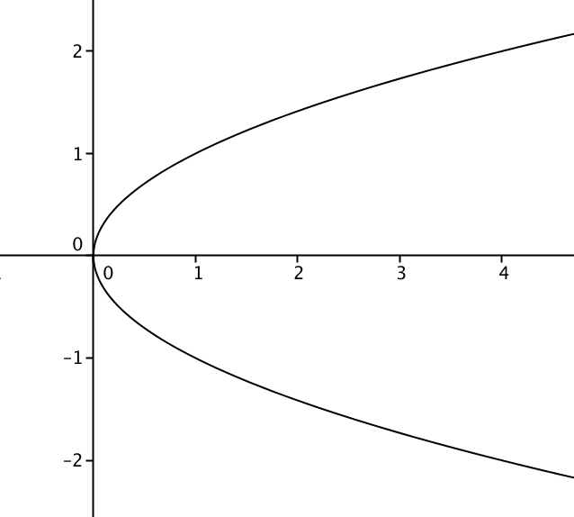

y-axis $f\left(x\right)=f(-x)$

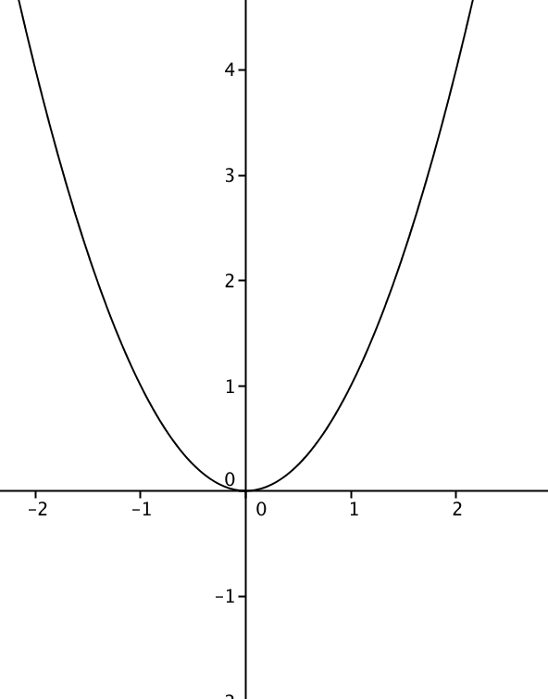

origin $f\left(-x\right)=-f(x)$
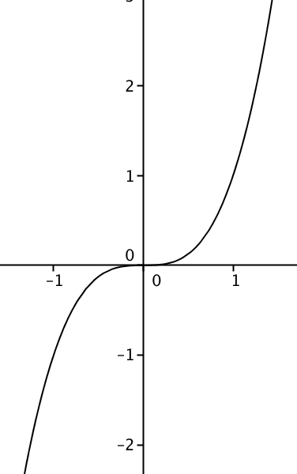

Different Symmetries

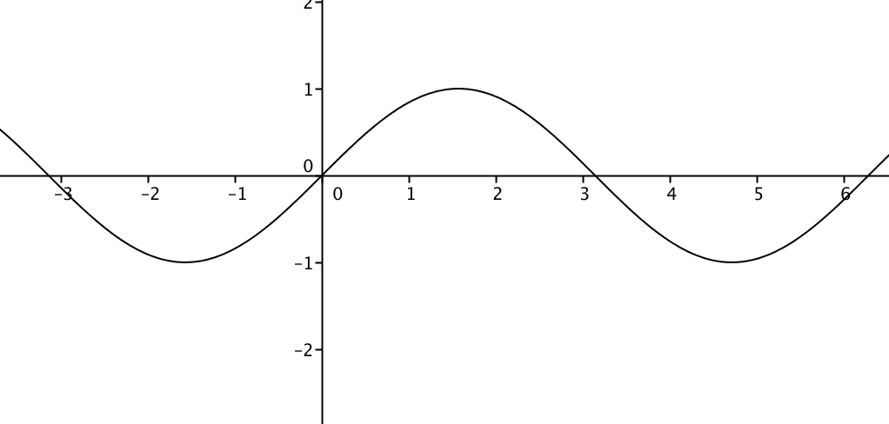

Line Symmetry at $x=\frac{(2k+1)π}{2} or \frac{(2k-1)π}{2}$ Point Symmetry at $(kπ, 0)$
k is an integer

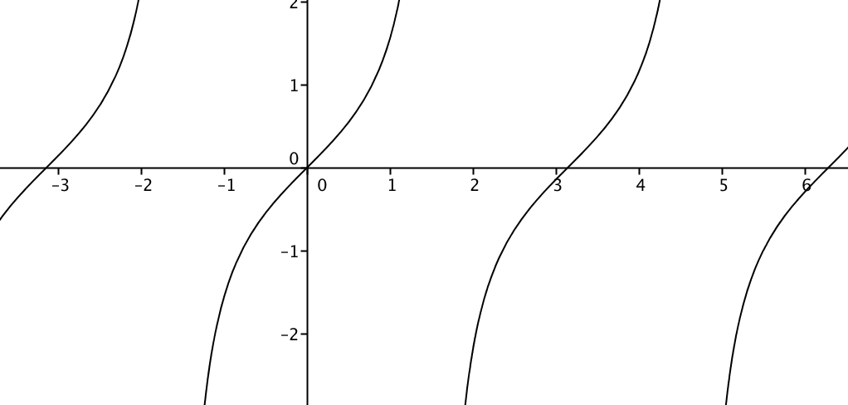

Point Symmetry at $(kπ, 0)$

Inequalities ------0++++++

$x>3$ 3 $[3, ∞)$

++++ 0 ----- 0 ++++++
$x\left(x-2\right)<0$
-1 0 1 2 3 (0, 2)

---0+++0+++0+++

$x^{2}\left(x+3\right){\left(x-2\right)}^{4}≥0$
-4 -3 -1 0 1 2 3 $[-3, ∞)$

$\frac{{\left(x-5\right)}^{2}}{x+3}<0$ ----- und++ 0 +++
-4 -3 0 5 6
Multiply by ${\left(x+3\right)}^{2}$

$\left(x+3\right){\left(x-5\right)}^{2}<0$ $(-∞, -3)$

